**Spark Architecture Overview**

Spark is designed for distributed data processing. The architecture of Spark is relatively simple but powerful, involving various components that work together for efficient data processing in parallel.

In Spark, the main components include:

1. **Driver Program**: Controls the execution of Spark jobs.
2. **Cluster Manager**: Manages resources in the cluster.
3. **Worker Nodes**: Host the execution environment (executors).
4. **Executors**: Perform the tasks assigned by the Driver.
5. **Task**: The smallest unit of work, which is executed by the executors.
6. **RDD**: The core abstraction for distributed data, which is **immutable**.

**Detailed Flow of Spark Architecture**

1. **Driver Program**:
   * The **Driver** is the **master** program that runs on the **client machine** (often referred to as the gateway node in some environments).
   * It is responsible for:
     + Coordinating the execution of the Spark application.
     + Creating the **SparkContext**, which acts as the connection to the cluster.
     + Submitting Spark jobs to the cluster.
     + Dividing jobs into stages, which are further divided into tasks.
     + Assigning tasks to the **Worker Nodes** for execution.
     + Collecting and processing the results once all tasks are completed.
2. **Cluster Manager**:
   * Spark can run on various cluster managers like **YARN**, **Mesos**, or **Standalone**.
   * The **Cluster Manager** is responsible for:
     + Allocating resources (memory, CPU) across the cluster.
     + Managing the worker nodes and ensuring the Spark job is executed correctly.

The **Cluster Manager** has two main components:

* + **Resource Manager** (also known as **Master** in standalone mode): Manages resource allocation across the cluster.
  + **Worker Nodes**: Machines where the actual work is carried out. They run the **executors** which process tasks.

1. **Resource Manager**:
   * The **Resource Manager** is the central component in the **Cluster Manager**. In a YARN-based setup, it is responsible for:
     + Managing the resources in the cluster.
     + Communicating with **Worker Nodes** to allocate resources for tasks.
     + Coordinating the job execution across the cluster.
2. **Worker Nodes**:
   * **Worker Nodes** are machines (or processes) that **actually execute** the tasks assigned by the Driver program.
   * Each worker node runs an **executor**, which is the **execution environment** for Spark tasks.
   * Worker nodes also store **data** (as part of the Spark application's execution), although the storage can vary depending on the cluster manager.
3. **Executors**:
   * Executors are responsible for:
     + Running tasks (or the units of computation) assigned by the Driver.
     + Storing the data that is being processed in-memory during the execution.
   * Each worker node can run multiple executors, and each executor runs a part of the job’s tasks.
   * Executors are responsible for reporting the progress of the tasks to the **Driver**.
4. **Task**:
   * Tasks are the **smallest unit of work** in Spark.
   * A Spark job is divided into several stages, and each stage contains tasks that are executed in parallel on different worker nodes.
5. **Driver vs. Application Master**:
   * In Hadoop (YARN), the **Application Master** is responsible for managing resources and executing tasks for a particular application.
   * In Spark, this role is fulfilled by the **Driver**. The **Driver** manages the entire job execution, including:
     + Dividing the job into tasks.
     + Requesting resources from the **Cluster Manager**.
     + Coordinating the execution of the tasks across **Worker Nodes**.

**Execution Flow in Spark**

1. **Job Submission**:
   * When a user submits a Spark job, the request goes to the **Driver**.
   * The Driver creates the **SparkContext**, which establishes a connection to the **Cluster Manager**.
   * The **Cluster Manager** allocates resources (memory and CPU) on the worker nodes.
2. **Job Division**:
   * The **Driver** splits the job into **stages**, based on **transformations** (like map(), filter()) that can be executed in parallel.
   * These stages are further divided into **tasks** that can be executed on different worker nodes.
3. **Task Execution**:
   * The **Cluster Manager** ensures the resources are allocated to run tasks on the **Worker Nodes**.
   * **Executors** on the worker nodes run the tasks in parallel.
   * If data is required to be transferred between workers (e.g., in a **shuffle** operation), the **Executor** will fetch the necessary data from other workers.
4. **Data Locality**:
   * Spark tries to maximize **data locality** by assigning tasks to the worker nodes where the data is already available, minimizing network overhead.
   * If a task requires data from another worker node, Spark will request the data from the appropriate worker node, ensuring **efficient data processing**.
5. **Task Completion**:
   * Once a task completes, the **Executor** sends the results back to the **Driver**.
   * The **Driver** coordinates the overall execution and collects the results from all tasks.
6. **Final Output**:
   * After all tasks are executed and results are gathered, the **Driver** performs the final operation (like writing data to a file or database).

**Comparison with Hadoop’s YARN (Application Master):**

* In **Hadoop**, the **Application Master** is responsible for managing resources and execution across containers. It requests resources from the **Resource Manager**, coordinates the **task execution**, and interacts with the **NameNode** for data locality (where the blocks are stored).
* In **Spark**, the **Driver** serves a similar purpose. The **Driver** divides the job into tasks and stages, allocates resources through the **Cluster Manager**, and manages the task execution. The **Executor** processes the tasks, and data is processed in a distributed manner across the **Worker Nodes**.

**Summary of Spark Architecture**

* **Driver**: Manages the job execution, splits tasks, and coordinates with the cluster manager.
* **Cluster Manager**: Manages resources across the cluster.
* **Worker Nodes**: Execute tasks and host executors.
* **Executors**: Run tasks, store data, report progress to the driver.
* **RDDs**: Core data abstraction; immutable collections of data distributed across the cluster.

**What is Uber Mode?**

Uber Mode is a mode where Spark runs **all of its components** (including both **Driver** and **Executors**) on a **single machine**. This configuration is typically used for testing, debugging, or processing small workloads, where full-scale distributed processing is unnecessary.

In **Uber Mode**, there is no need for a cluster manager like YARN, Mesos, or a dedicated Spark cluster. Everything, including the execution of tasks, is carried out on the same machine. This mode simulates distributed execution locally without involving multiple nodes, making it simpler and more convenient for local development or small-scale jobs.

Uber Mode was introduced in **Spark 1.x** as a **simplified** execution mode for Spark applications, especially useful during the **development and testing phases**.

**How Uber Mode Works**

1. **Local Execution**:
   * In Uber Mode, Spark runs the entire Spark application (Driver and Executors) on a **single machine**, typically the client machine from which the job is submitted.
   * Spark uses **local resources** (CPU and memory) on the machine to run both the Driver and Executor processes.
2. **Single Node Operation**:
   * The driver program and the executors **do not** communicate over a network, as both run on the same node.
   * The **executor processes** are all run in local threads inside the JVM, and they can run as separate processes, but everything happens on one machine, ensuring all resources (memory, CPU) are used on that machine.
   * The driver runs in the same JVM as the executors, which means the driver controls all execution in this mode.
3. **No Cluster Manager**:
   * Uber Mode doesn’t require the use of a cluster manager like YARN or Mesos because Spark is running on a single machine. There’s no need to worry about resource allocation across multiple nodes or containers.
   * It operates **locally**, making it simple for users who want to test their applications on a small scale before deploying them to a full cluster.
4. **Parallel Execution**:
   * Even though it is running on a single machine, Spark can still perform **parallel execution** by creating **multiple tasks** in parallel on different threads or cores of the machine.
   * It is possible to run multiple **executors** in Uber Mode, but all of them run within the same machine. The driver will distribute tasks across multiple executors, simulating parallel processing in a cluster-like manner.

**Configuration of Uber Mode**

To run Spark in Uber Mode, you would typically configure the **spark.master** parameter to local[*], where [*] allows Spark to use all available cores on the local machine.

For example, you might use the following in your Spark application:

python

conf = SparkConf().setMaster("local[*]").setAppName("UberModeExample")

sc = SparkContext(conf=conf)

In this case:

* local[*] tells Spark to run in local mode and use all available CPU cores.
* setAppName is just the application name for logging purposes.

**Features of Uber Mode**

1. **Simplified Development and Testing**:
   * It is easy to test Spark code in a local environment without needing to set up a full Spark cluster.
   * Useful for small-scale jobs, debugging, and experimentation.
2. **Parallelism on Local Resources**:
   * Despite running on a single machine, Uber Mode can still take advantage of **parallelism** by using multiple CPU cores to run tasks in parallel (depending on the number of available cores on the machine).
3. **No Need for a Cluster Manager**:
   * Spark in Uber Mode operates **without** a cluster manager, simplifying the setup process for developers.
4. **Low Overhead**:
   * It avoids the overhead of network communication and inter-node coordination, which can be an advantage in environments where you don’t need distributed execution.
5. **Great for Small Jobs**:
   * Ideal for jobs that don't require the distributed scale of a full Spark cluster (for example, small datasets or jobs that don't take advantage of distributed data storage).

**Limitations of Uber Mode**

1. **Not Scalable**:
   * Uber Mode is not scalable, as everything runs on a single machine. It does not have the distributed computing power required for large-scale data processing, and it is limited by the hardware of that single machine.
2. **Memory and CPU Limitations**:
   * Since everything is running locally, **memory** and **CPU** resources are restricted to what the local machine can handle.
   * Spark’s default in-memory processing, especially with large datasets, can easily exceed local resources.
3. **Not Suitable for Large Jobs**:
   * This mode is only practical for small jobs, like testing or running smaller datasets. Large-scale data processing jobs will fail to perform or crash due to memory overflow or CPU bottlenecks on a single machine.
4. **Single-Point Failure**:
   * Running everything on one machine means if that machine fails, the entire job execution is interrupted. This is in contrast to distributed execution where jobs can continue even if one node fails.

**When to Use Uber Mode**

* **Development**: When developing Spark applications, Uber Mode allows developers to test code and debug in a local environment without setting up a full cluster.
* **Prototyping**: Quick experimentation or prototyping of Spark jobs can be done easily in Uber Mode.
* **Small-scale Jobs**: If your data is small enough to be processed on a single machine (e.g., for batch processing, small datasets), Uber Mode can be an efficient option.

**Uber Mode vs. Other Execution Modes (Standalone, YARN, Mesos)**

| **Feature** | **Uber Mode** | **Standalone Mode** | **YARN (Hadoop)** | **Mesos** |
| --- | --- | --- | --- | --- |
| **Cluster Manager** | No Cluster Manager | Spark’s own standalone cluster | YARN Resource Manager | Mesos Resource Manager |
| **Deployment** | Single node (Local mode) | Cluster of Spark workers | Distributed, managed by YARN | Distributed, managed by Mesos |
| **Parallelism** | Limited to local resources (single machine) | Distributed across cluster nodes | Distributed across multiple nodes | Distributed across multiple nodes |
| **Scalability** | Not scalable (limited by local resources) | Scalable, limited by cluster size | Highly scalable | Highly scalable |
| **Fault Tolerance** | Single point of failure | Limited (depends on Spark setup) | Fault-tolerant, high availability | Fault-tolerant, high availability |
| **Use Cases** | Testing, development, small jobs | Small to medium-sized workloads | Large-scale jobs, big data | Large-scale jobs, big data |

**Conclusion**

Uber Mode is essentially a local, non-distributed mode for running Spark jobs. It is primarily useful for development, testing, and running small-scale jobs on a single machine. It offers simplicity and convenience but lacks the scalability, fault tolerance, and resource distribution capabilities that Spark provides in cluster-based modes like **Standalone**, **YARN**, or **Mesos**. For large-scale production workloads, you would typically rely on Spark running in a distributed cluster mode rather than Uber Mode.

**Handling Nulls in Apache Spark**

Dealing with null values in Apache Spark is crucial for ensuring data quality, avoiding errors, and improving performance. Spark provides multiple ways to handle nulls, such as filtering, replacing, or imputing missing values.

**1. Identifying Null Values**

Before handling nulls, it's important to identify them. In Spark, null values appear as None in Python.

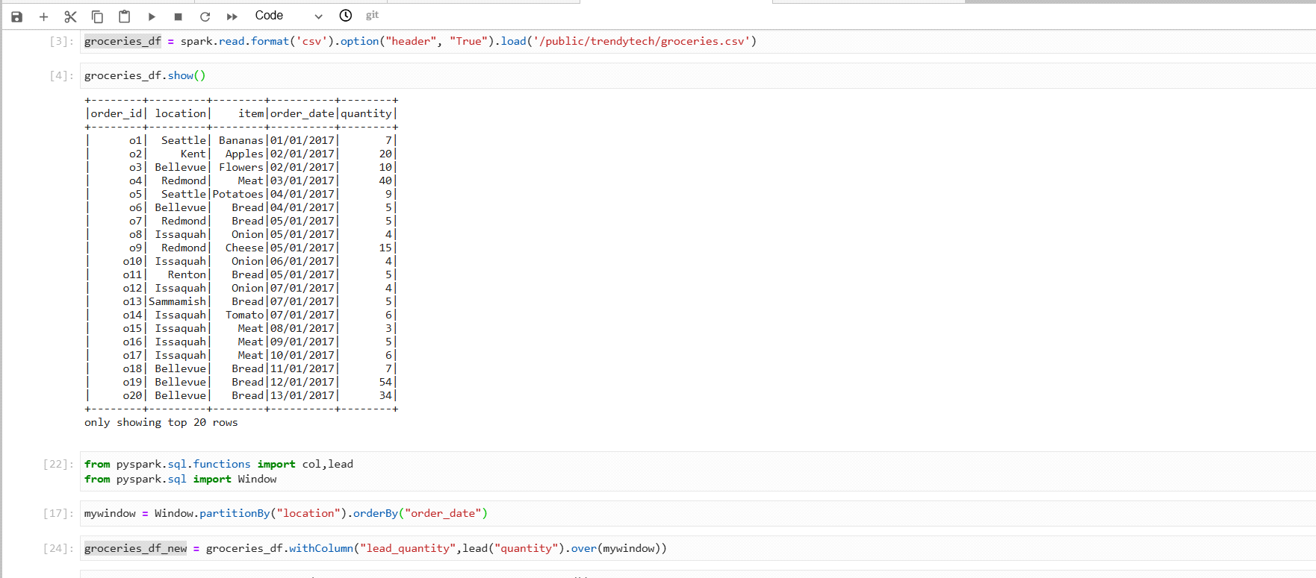

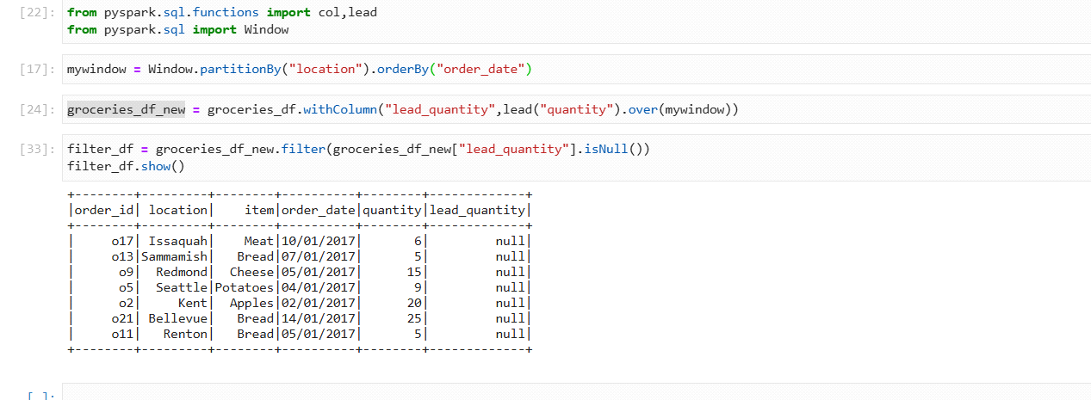

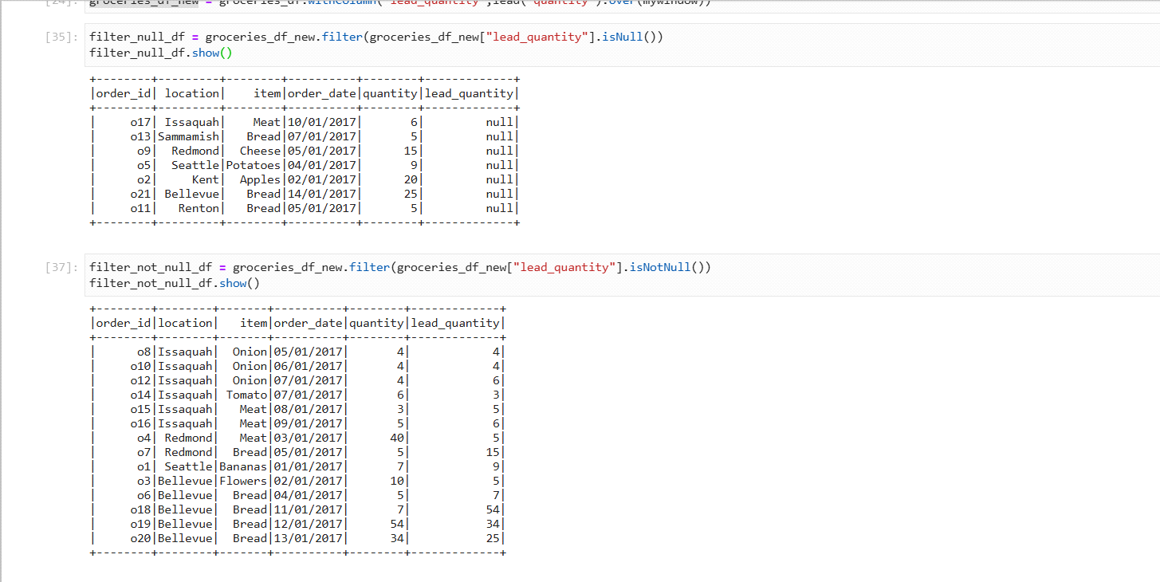

**2. Filtering Out Null Values**

**a) dropna(): Removing Rows with Nulls**

* **df.na.drop(how="any")** (default) removes rows with any nulls.
* **df.na.drop(how="all")** removes rows where all columns are null.
* **df.na.drop(subset=["column_name"])** removes rows where a specific column is null.

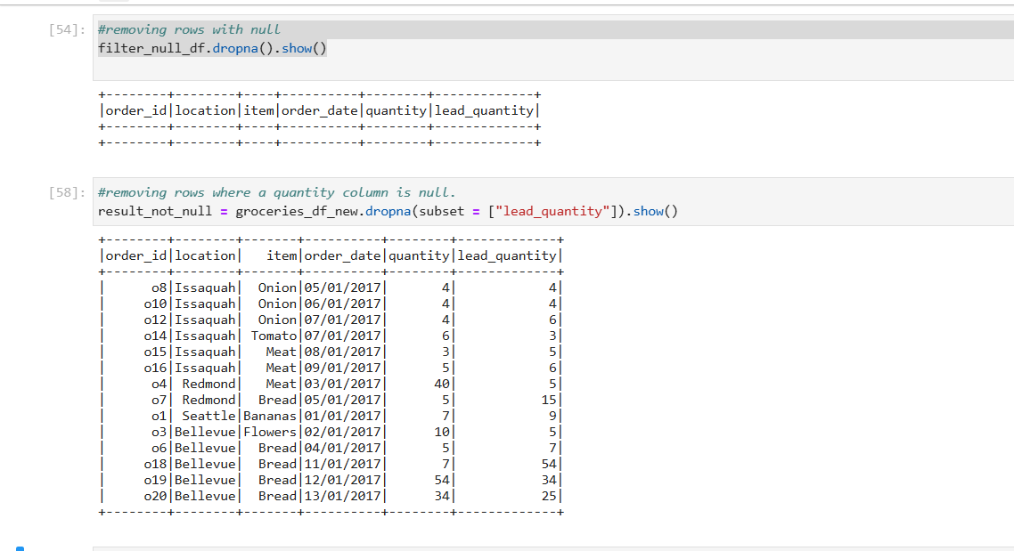

**3. Replacing Nulls**

**a) fillna(): Replacing Nulls with Specific Values**

You can replace nulls using fillna(), either globally or for specific columns.

df.fillna("NA").show()

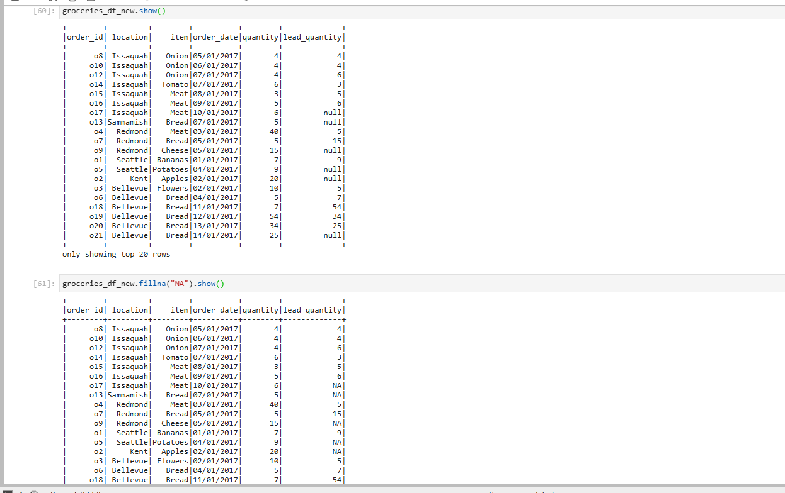

df.na.fill({"name": "Unknown", "state": "No State"}).show()

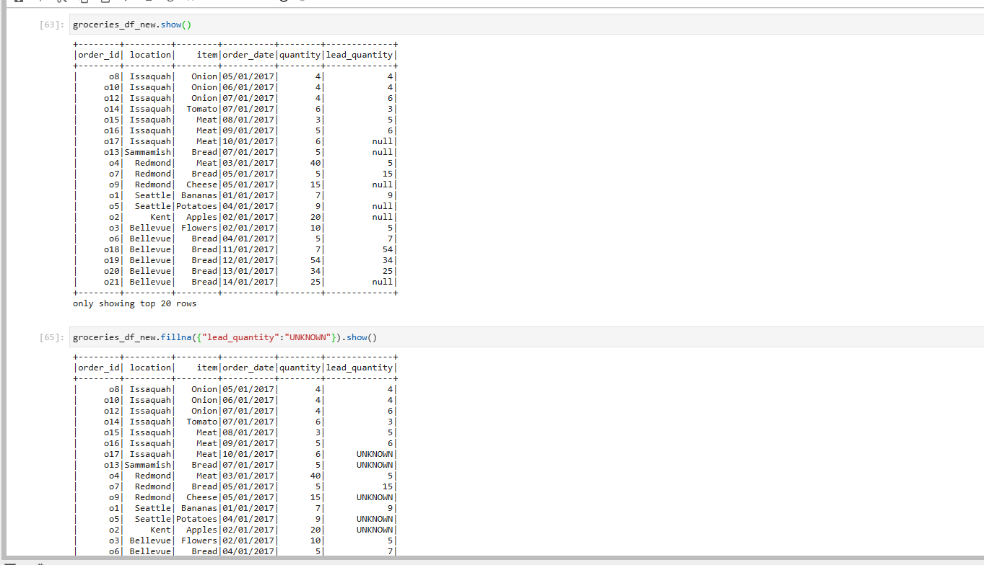

**4. Replacing Nulls with Column-Wise Computed Values**

**a) Using coalesce()**

coalesce() returns the first non-null value from a list of columns.

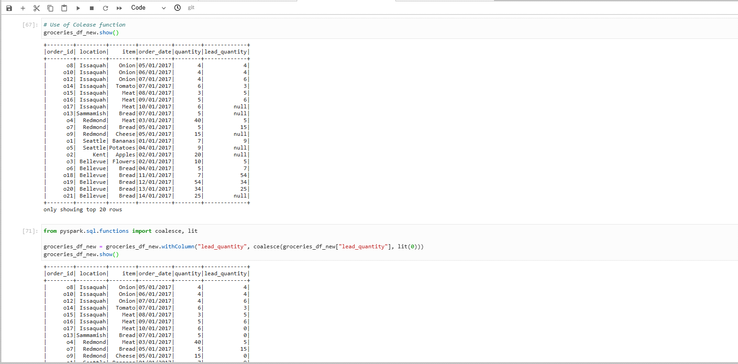

**5. Handling Nulls in Expressions**

**a) ifnull(), nvl(), nvl2()**

* ifnull(col, default): Returns default if col is null.
* nvl(col, default): Same as ifnull()
* nvl2(col, value_if_not_null, value_if_null)

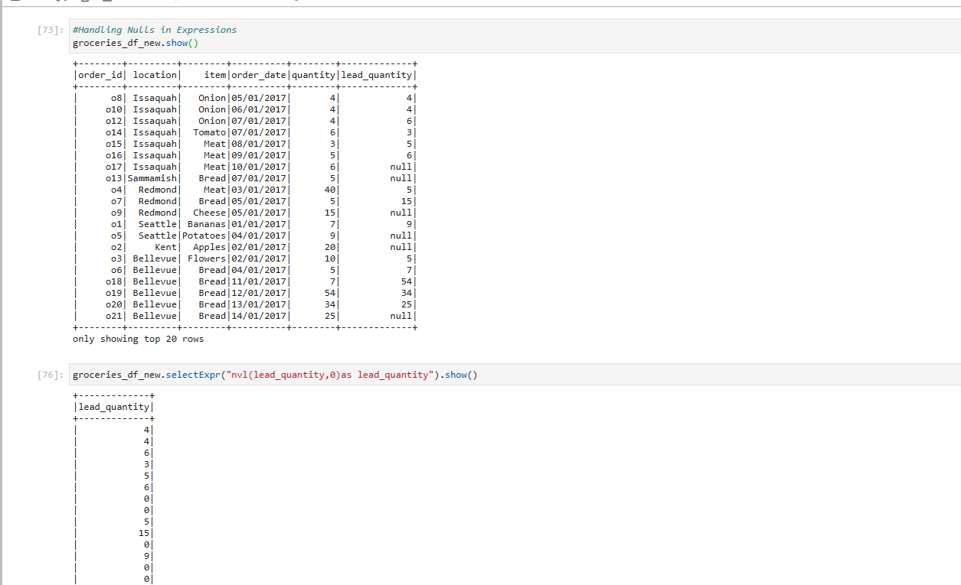

**7. Handling Nulls in Aggregations**

By default, Spark ignores null values in aggregations.

**a) Using count()**

df.selectExpr("count(state)").show()

* This ignores null values.
* To include nulls: df.selectExpr("count(*)").show()

**b) Using sum(), avg(), min(), max()**

Spark ignores nulls by default in these functions:

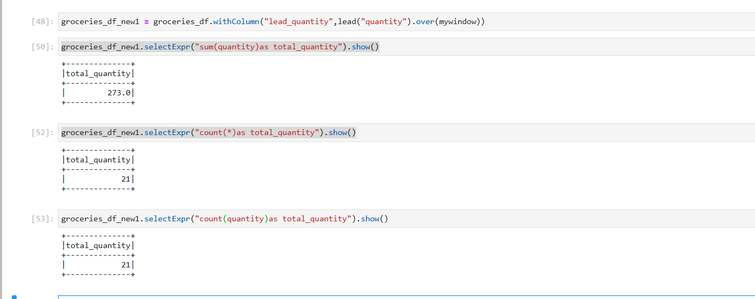

**Resource UI**

The **Resource UI** is an important interface in Spark (and other distributed computing frameworks like YARN or Mesos) that provides insights into the cluster’s resource utilization and job execution details. It allows users to monitor and troubleshoot their Spark jobs and track the status of the resources being allocated to the application. The UI can be accessed through a web browser and typically provides several views, including the **Application UI** and the **Cluster Manager UI**.

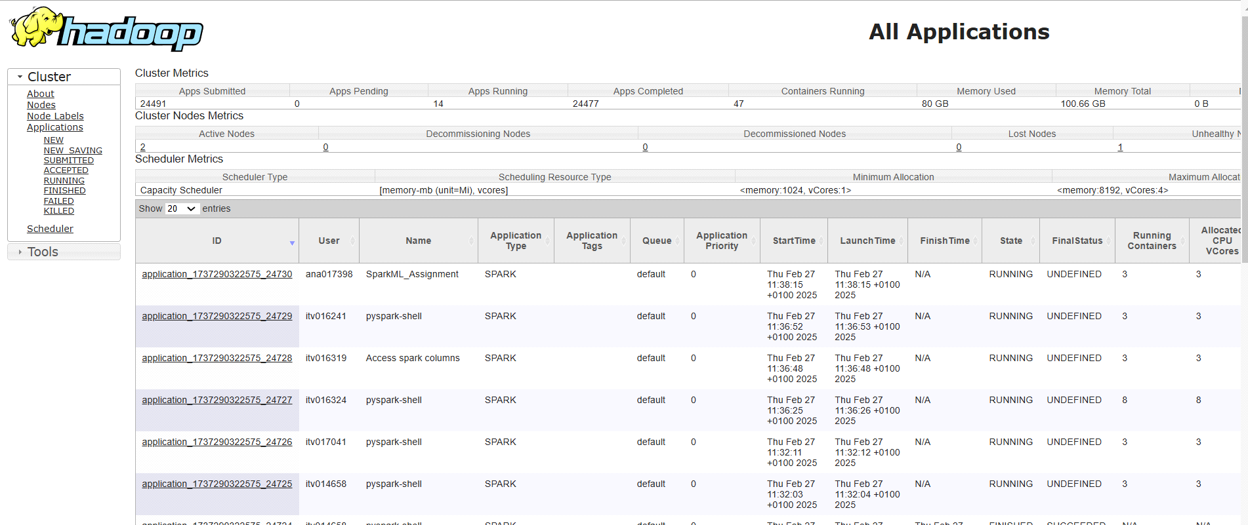

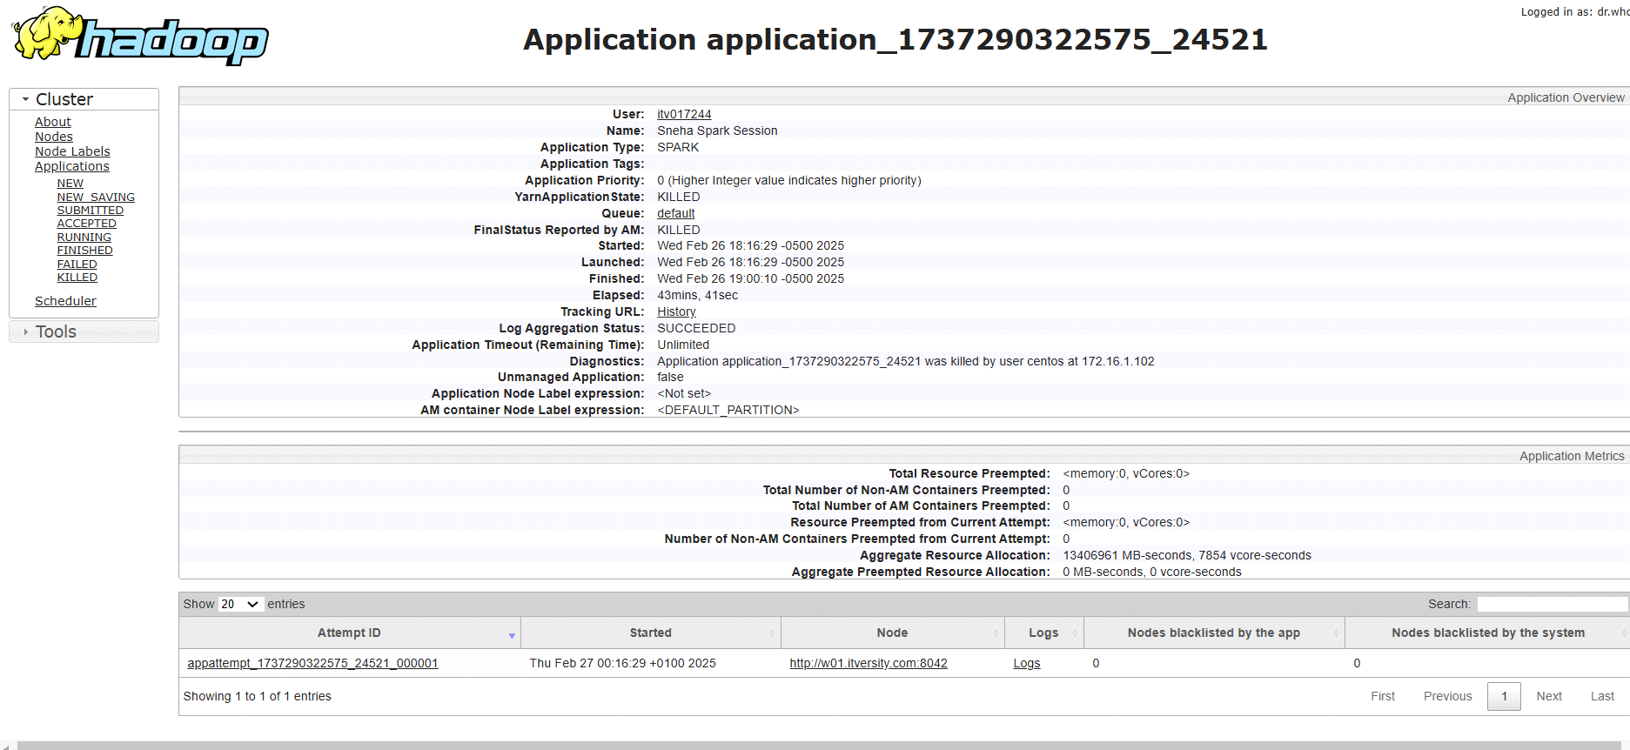

**Key Features of the Resource UI**

* **Driver and Executor Information**:
* The **Resource UI** provides detailed information about the driver and executors in the cluster, including:
* The **status** of executors (running, completed, failed).
* **Memory usage** and **disk usage** per executor.
* **Executor logs**, including stdout and stderr, for debugging.
* **Task execution time** per executor.

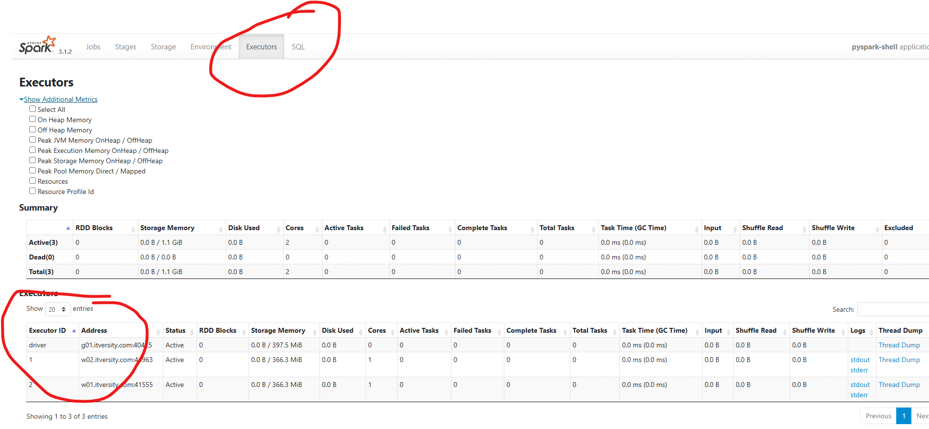

* **Job Details**:
* The UI gives an overview of **jobs** running on the cluster, including:
* **Job stages**: A job is divided into multiple stages. Each stage is made up of tasks that run in parallel on the executors.
* **Task progress**: This includes details like how many tasks have completed, how many are pending, and how many have failed.
* **Duration** of each job, stage, and task.

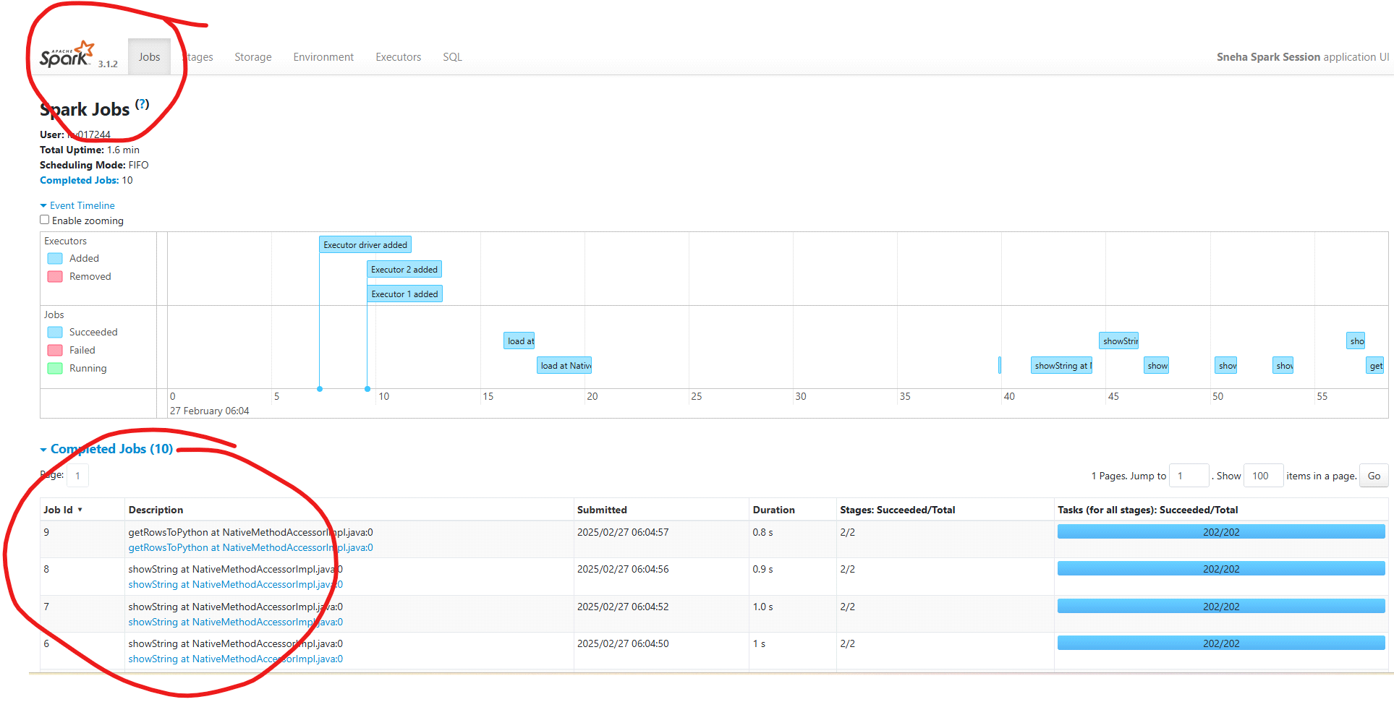

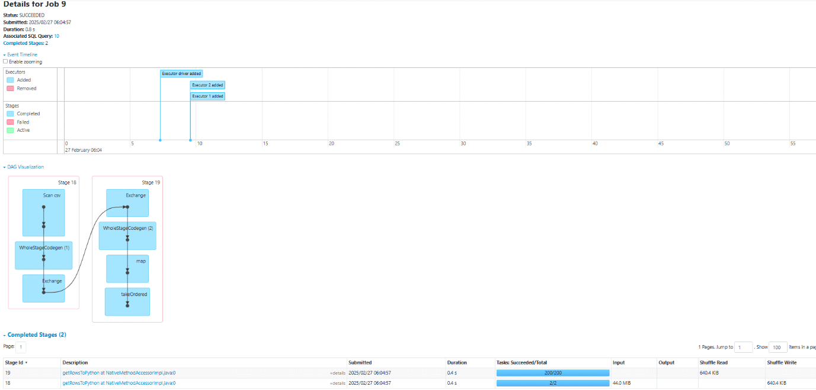

* **Task Metrics**:
* For each task in the job, the Resource UI will show:
* **Task start time**, **end time**, and **duration**.
* **Task status**: Whether the task was successful, failed, or pending.
* **Task shuffle statistics**: This includes information about data shuffled between executors, which helps optimize performance.

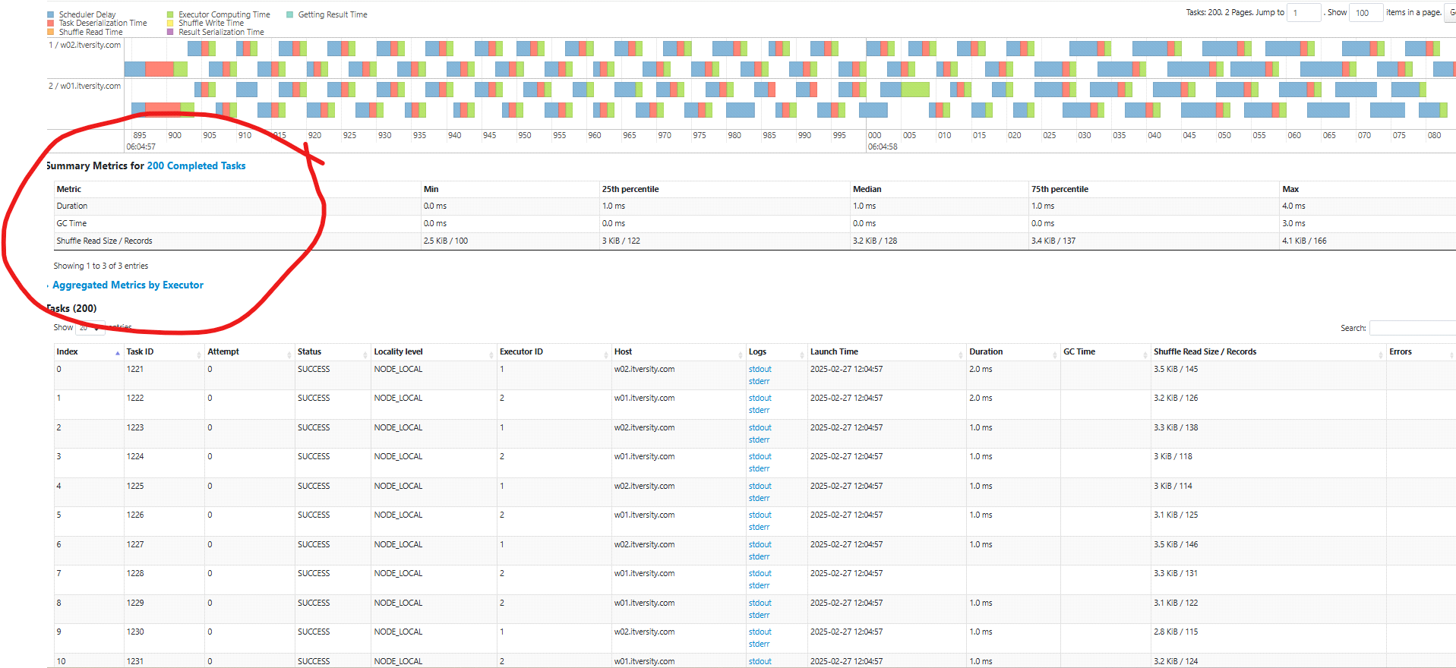

* **Cluster Resource Utilization**:
* The UI provides an overview of the **resources available** in the cluster, such as:
* **Total memory**, **core count**, and **storage capacity** of the worker nodes.
* **Resource allocation** to each job, including how many **cores** and how much **memory** are allocated to each executor.
* **Resource usage**: A chart or table showing the actual usage of resources over time, helping you spot bottlenecks or underutilized resources.

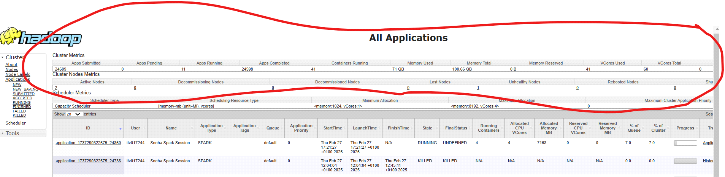

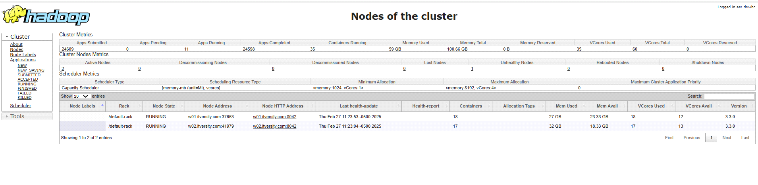

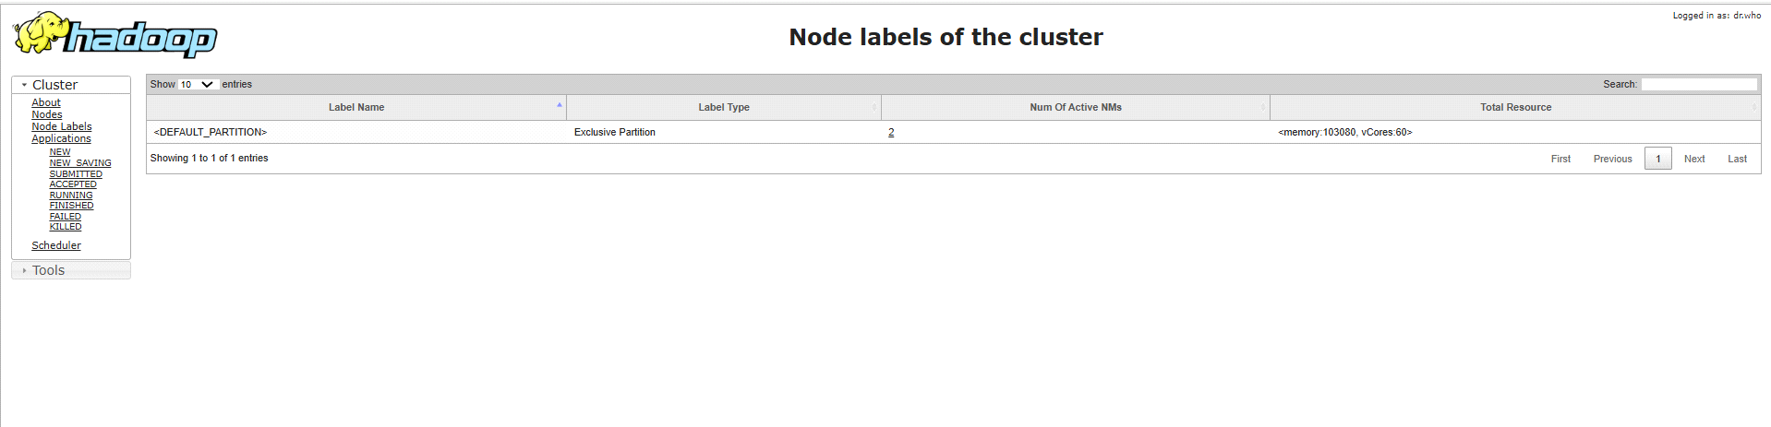

* **Stage and Task Scheduling**:
* The **Resource UI** shows how the tasks are scheduled across the available worker nodes and provides insight into **task locality**. This helps optimize performance by ensuring tasks are scheduled closer to the data (i.e., **data locality**).

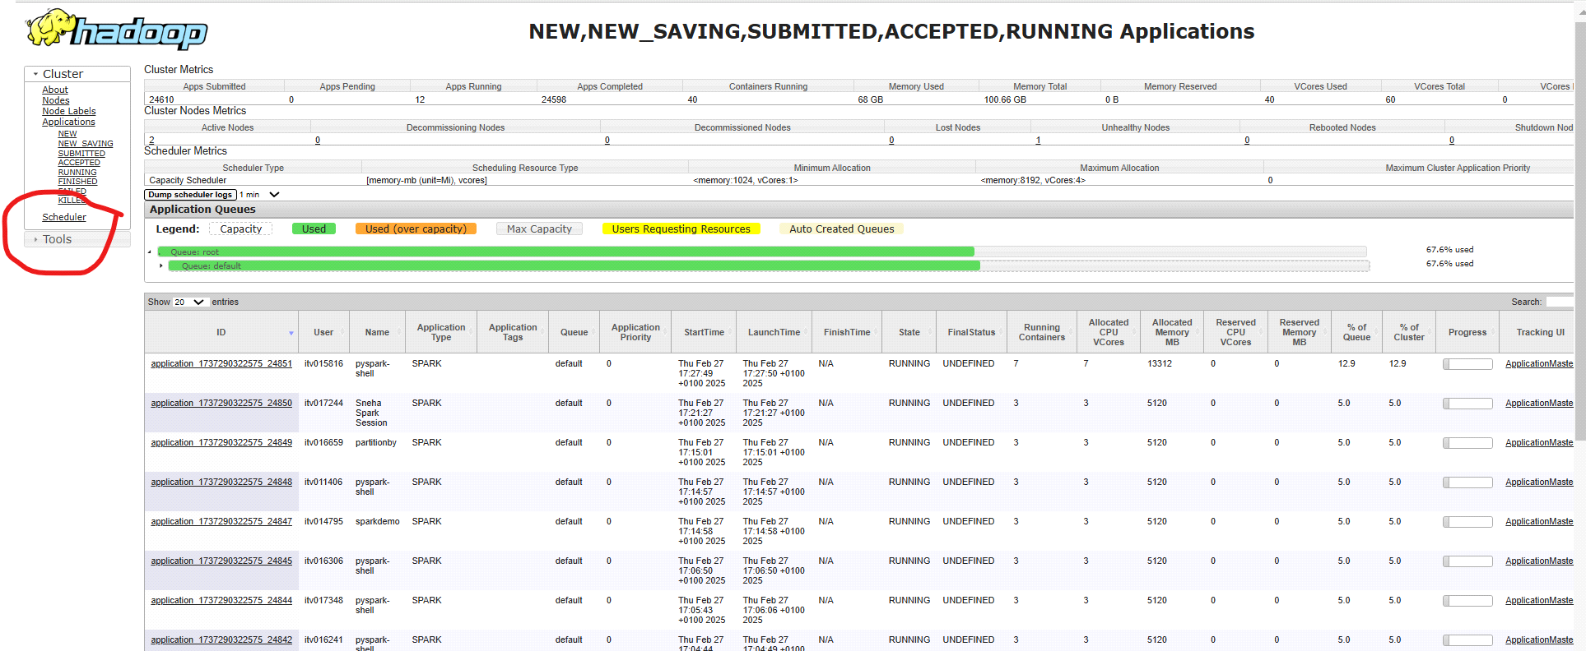

* **Logs and Error Tracking**:
* The UI allows users to access **logs** for both the driver and the executors. The logs are extremely useful for:
* Diagnosing failed tasks.
* Understanding performance issues.
* Debugging application errors.

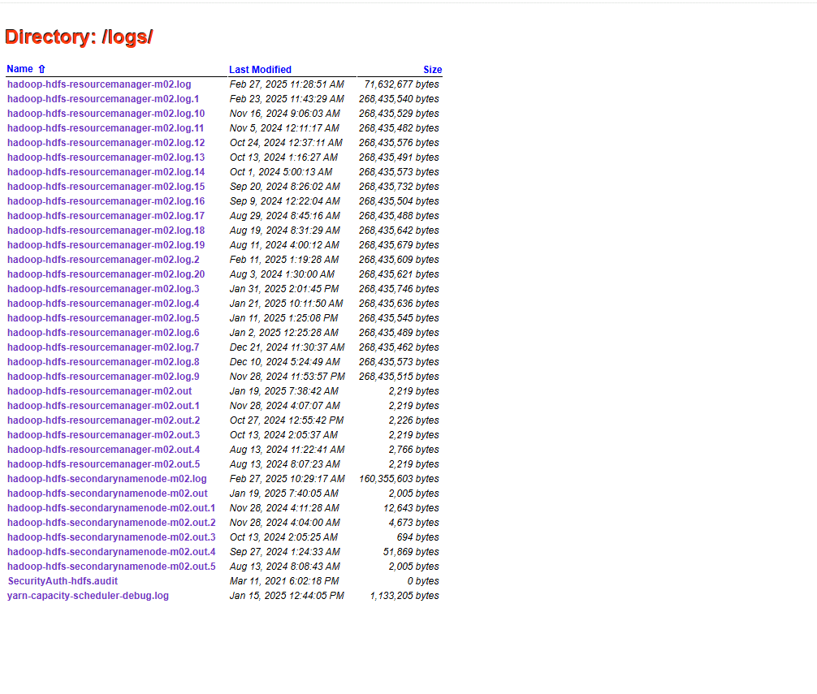

* **Job and Stage Visualization**:
* The **UI** often includes visualizations of the **job DAG (Directed Acyclic Graph)**, showing how jobs are divided into stages and tasks.
* This visualization helps in understanding the flow of the Spark application, where parallelization happens, and how stages are dependent on each other.

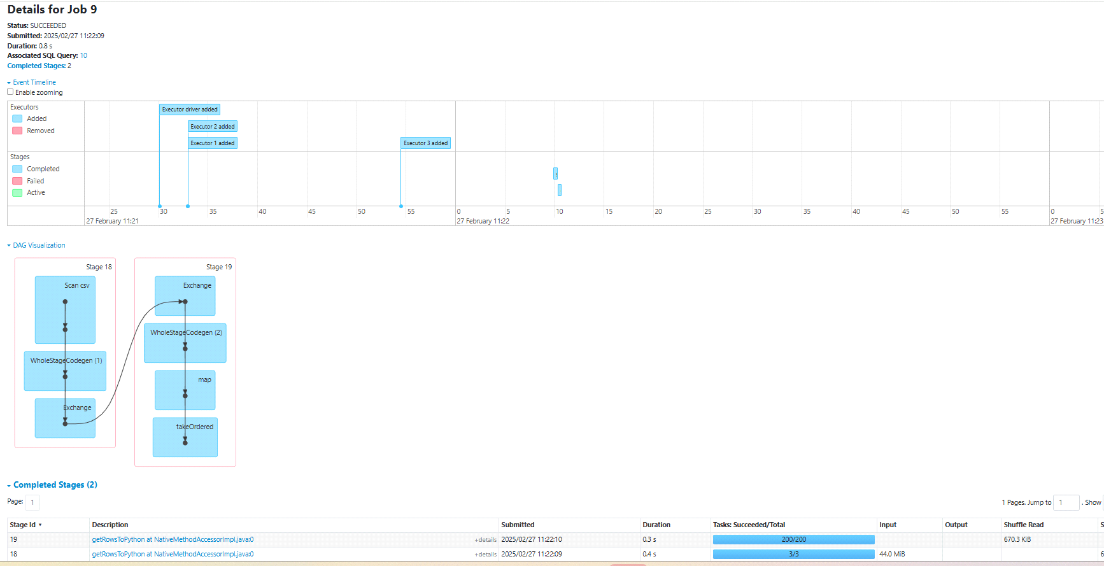

* **Job, Stage, and Task Failures**:
* The UI shows the **status of failed tasks** or stages, providing useful information about why a failure occurred and how it can be addressed.
* It also includes the option to **retry failed tasks** from the UI, if the job allows it.

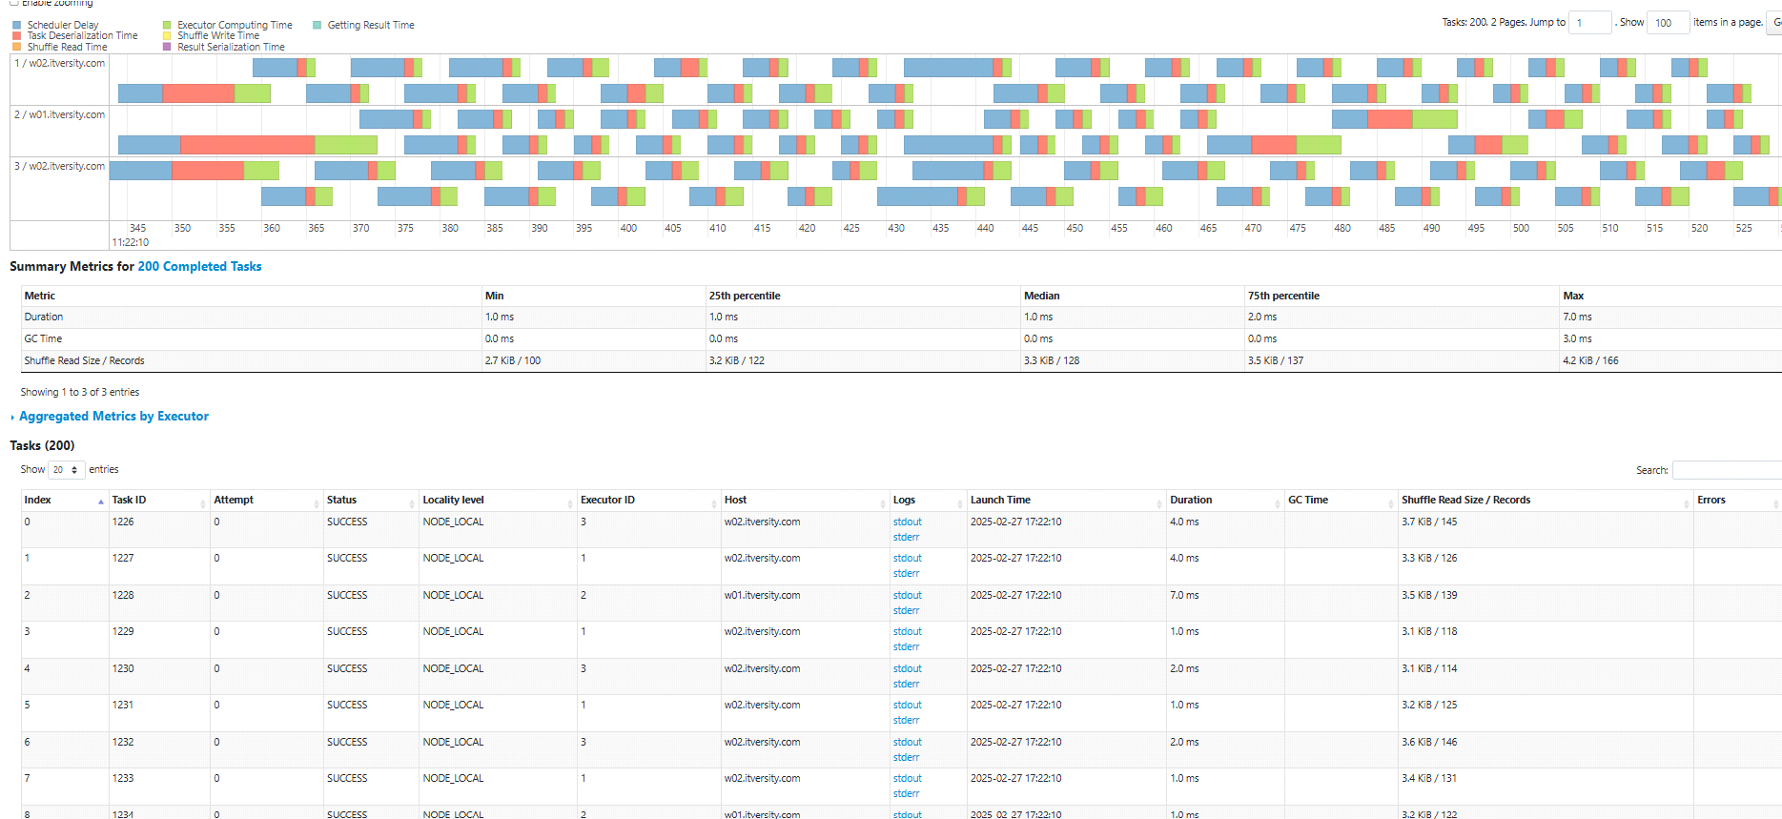

* **Executor Logs and Storage**:
* For each executor, the UI provides detailed storage information:
* How much memory is being used for **in-memory caching**.
* How much data is being spilled to **disk**.
* Memory and disk **overheads**.

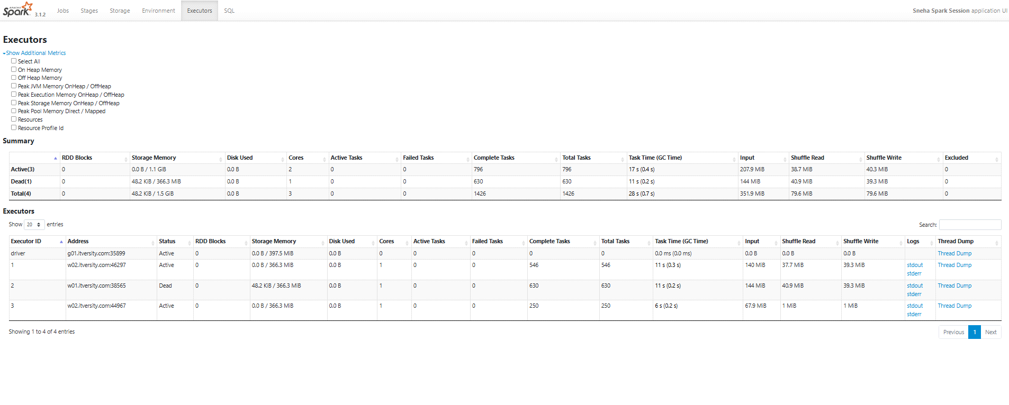

**Benefits of the Resource UI**

* **Performance Monitoring**: It helps monitor the performance of your Spark application by providing real-time insights into resource usage, task execution, and memory utilization.
* **Troubleshooting**: The detailed logs and task information help debug issues with job execution, task failures, or resource allocation.
* **Optimization**: By observing where resources are being underutilized or tasks are taking too long, the UI helps you optimize your Spark job configuration for better performance.
* **Resource Allocation and Efficiency**: You can monitor how efficiently resources (memory, CPU) are being allocated across executors and adjust configurations accordingly for improved efficiency.

**Conclusion**

The **Resource UI** is a powerful tool for monitoring and managing resources in a Spark cluster. It helps with job tracking, resource allocation, and debugging, making it easier to manage large-scale distributed applications. Whether you're using Spark on a standalone cluster, with YARN, or Mesos, this UI provides valuable insights into how your Spark jobs are utilizing resources and how the cluster is performing.

ss